Name: | ___________________________________________________ |  |  |  | Date: ___________
 | Year 11 Mathematics: Applications  Investigation 1, 2015  Topic – Forensic Science  Take home component
Important Information:
Although the take-home component is not worth any marks, it is essential in preparation for the in-class component. Knowledge and skills gained will be extended in the in-class validation component. This in-class validation will be completed under test conditions on the day in which this take-home component is due. The take-home component may be used when completing the in-class component. Contact may be made to parent(s) if the take-home component is not available for submission (at the start of the lesson).
Date out: |  | Week ____ Date _____________ | Date Due: | Week ____ Date _____________
Take home component weighting: |  | 0% of the year | In-class component weighting: | 10% of the semester
AIM: In this assessment, you will be investigating how mathematics is used in solving crimes, through Forensic Science. You will be using your TI-Nspire CAS for this investigation, in particular the spreadsheet function.

Inspector Jack has been called to a burial site in Rockingham. Land sailors at Lake Walyungup have discovered some human bones, which have been identified as tibia, humerus and ulna. Inspector Jack thinks the bones are of the missing person Py Thagoras, a twenty-year old man who went missing five years earlier.
Dr Math is the Crime Scene Investigator (CSI) who has arrived to gather evidence.

Inspector Jack has asked Dr Math to describe how he can use the bones to determine the height of the body.

Dr Math explains that there are several rules that can be used to determine the height of the body. The formulas are different depending on whether the victim is male or female.

The table below shows these rules.
Height Estimation Equation | Male | Female
humerus (h) | H₁ = 3.08 h + 70.45 | H₁ = 3.36 h + 57.97
ulna (u) | H₂ = 3.70 u + 70.45 | H₂ = 4.27 u + 57.76
tibia (t) | H₃ = 2.52 t + 75.79 | H₃ = 2.90 t + 59.24

1. | Why are the rules for males and females different for each bone?

2. | For each of the following bones discovered, determine the height of the victim. Assume that the victims are all males.
a) | Tibia of length 45 cm | b) | Humerus of length 57 cm
c) | Ulna of length 31 cm

3. | For each of the following bones discovered, determine the height of the victim. Assume that the victims are all females.
a) | Tibia of length 38 cm | b) | Humerus of length 41 cm
c) | Ulna of length 28 cm

4. | Dr Math described a previous crime scene, where a man was found dead. Dr Math measured his humerus at  40 cm, his ulna at 34 cm and his tibia at 47 cm.
a) | For each bone discovered, calculate the predicted height of the victim.
b) | The police identified the victim as Carlos Sanchez, and discovered his actual height to be 195 cm. Comment on the accuracy of the predicted heights.

 | It can be annoying to enter the same rules into your calculator each time. You can use the spreadsheet function on your CAS calculator to enter formulas and compare results.
 | On the home screen, go to the Spreadsheet icon. | We are going to first look at the male bones.  In the first column, in the A box, type the letter ‘h’ and press enter. This is the humerus column. | In cell A1, type the number 1. This represents a humerus of 1 cm.  In cell A2, type  =a1+1  and press enter
 | 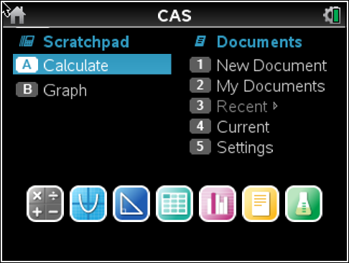 | 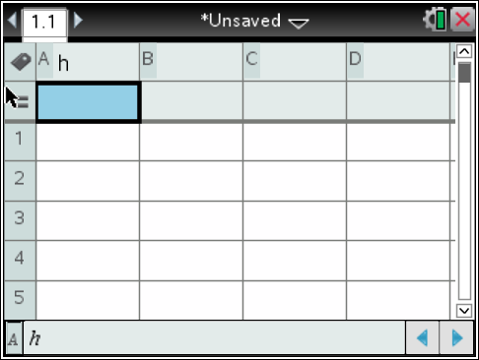 | 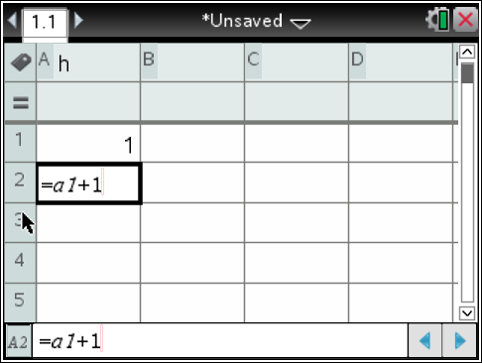
 | Use your arrow keys to go back up to cell A2 and make sure it is highlighted.  Next, press  Menu – Data – Fill  Use your down arrow key to select a large number of cells. I have chosen 100. You should notice that the cells have a broken line around them. Press enter to generate the values in the column. | Column B is going to be for the male height rule using the humerus.  In the second column, in the B box, type the letters ‘mh’ and press enter. | In the cell under B box, there is a formula box. If you use that box, you won’t need to manually enter the rule for each cell. It will also automatically generate the values to the end of column A.  Click in this cell. mh:= should be displayed  Type  3.08 × h + 70.45  and press enter.
 | 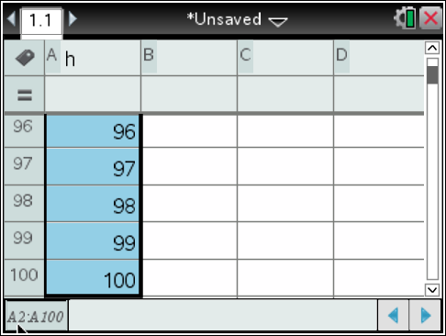 | 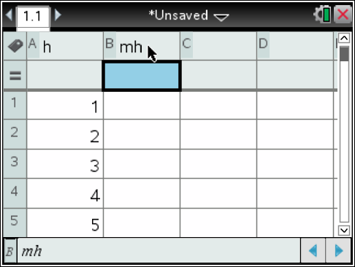 | 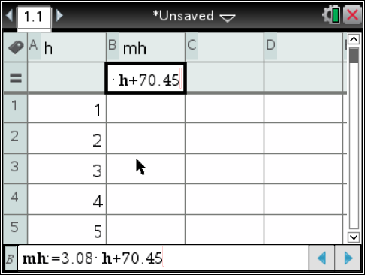
 | Your screen should now have this message: | We want the h to be a variable reference.  Press the across button, and then select varaible reference and press enter. Your data will be displayed. | We are going to now enter the data for the ulna.  In the third column, in the C box, type the letter ‘u’ and press enter.
 | 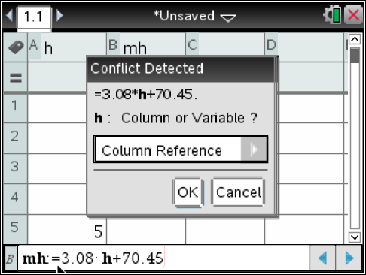 | 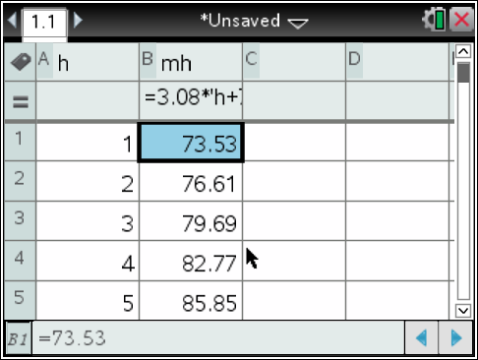 | 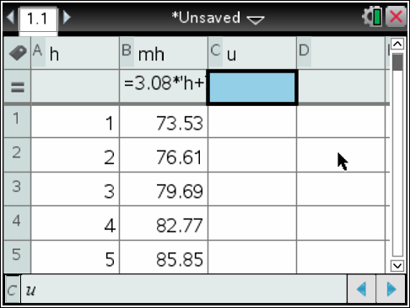
 | In cell C1, type the number 1. This represents an ulna of 1 cm.  In cell C2, type  =c1+1  and press enter  This will give you 2 cm. | Use your arrow keys to go back up to cell A2 and make sure it is highlighted.  Next, press  Menu – Data – Fill  Use your down arrow key to select a large number of cells. I have chosen 100. You should notice that the cells have a broken line around them. Press enter to generate the values in the column. | Column D is going to be for the male height rule using the ulna.  In the fourth column, in the D box, type the letters ‘mu’ and press enter.
 | 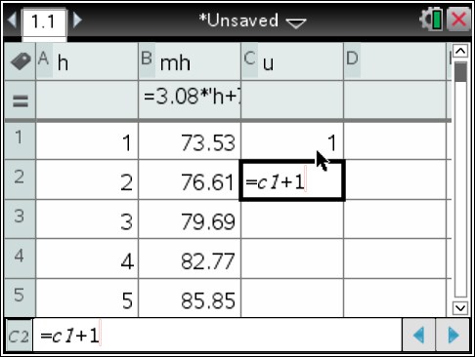 | 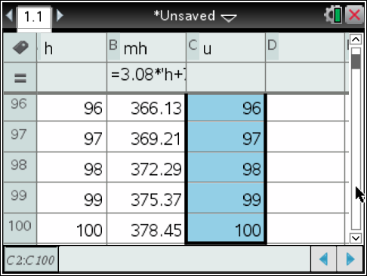 | 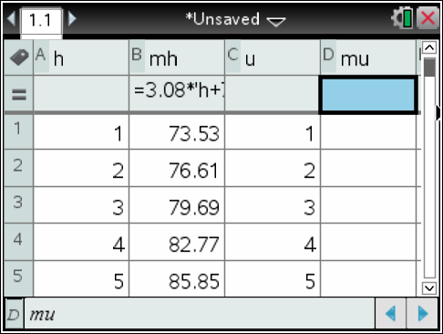
 | In the cell under D box, there is a formula box. If you use that box, you won’t need to manually enter the rule for each cell. It will also automatically generate the values to the end of column C.  Click in this cell. mu:= should be displayed  Type  3.70 × u + 70.45  and press enter. | Your screen should now have this message: | We want the u to be a variable reference.  Press the across button, and then select varaible reference and press enter. Your data will be displayed.
 | 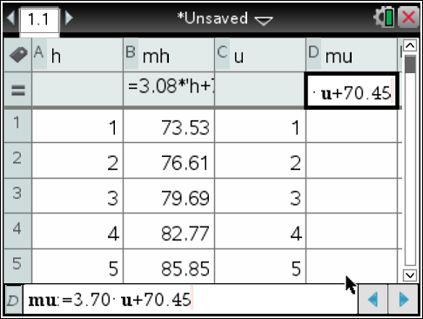 | 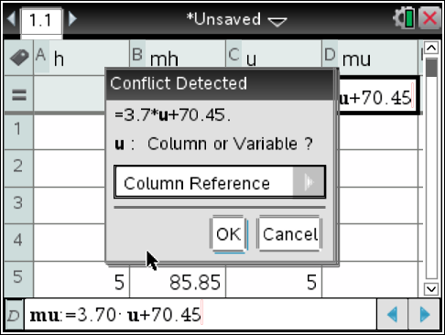 | 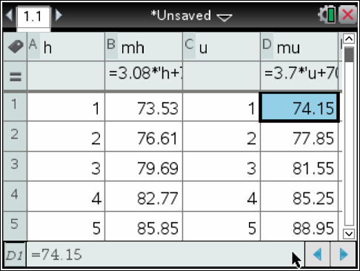
 | We are now going to look at the tibia.  In the fifth column, in the E box, type the letter ‘t’ and press enter. | In cell E1, type the number 1. This represents a tibia of 1 cm.  In cell E2, type  =e1+1  and press enter  This will give you 2 cm. | Use your arrow keys to go back up to cell E2 and make sure it is highlighted.  Next, press  Menu – Data – Fill  Use your down arrow key to select a large number of cells. Press enter to generate the values in the column.
 | 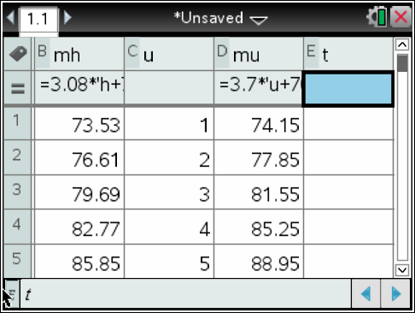 | 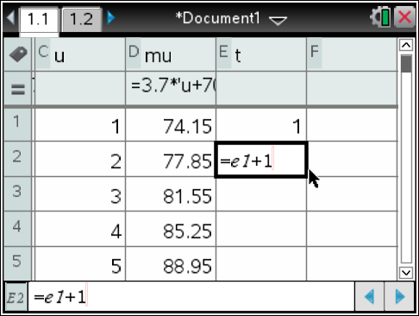 | 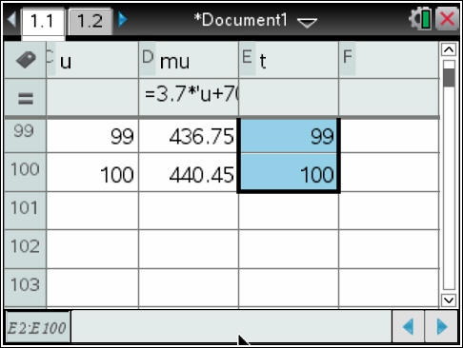
 | Column F is going to be for the male height rule using the tibia.  In the sixth column, in the F box, type the letters ‘mt’ and press enter. | In the cell under F box, there is a formula box. If you use that box, you won’t need to manually enter the rule for each cell. It will also automatically generate the values to the end of column C.  Click in this cell. mt:= should be displayed  Type  2.52 × t + 75.79  and press enter. | Your screen should now have this message:
 | 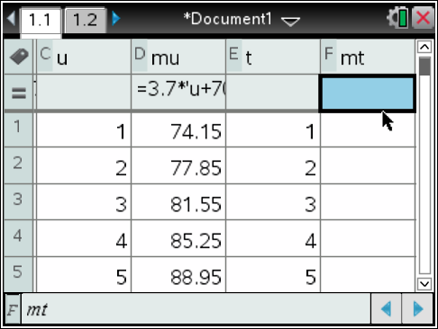 | 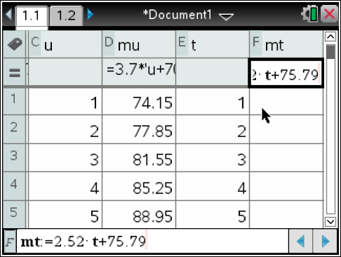 | 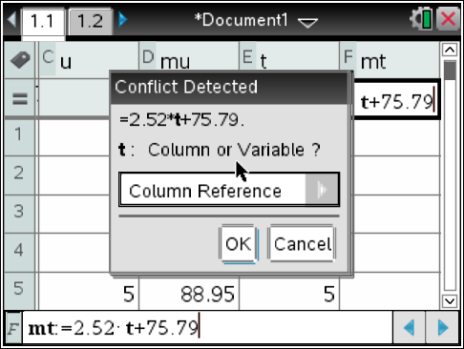
 | We want the u to be a variable reference.  Press the across button, and then select varaible reference and press enter. Your data will be displayed. | Next, we are going to look at the female bones. To do this, we will need a new Lists and Spreadsheets page.  Press CTRL+DOC.  This will insert a new page. Choose Lists and Spreadsheets. | As we have already defined the variables, our work setting up this spreadsheet is easier.  In the first column, in the A box, type the letter h and press enter.  The data will automatically generate.
 | 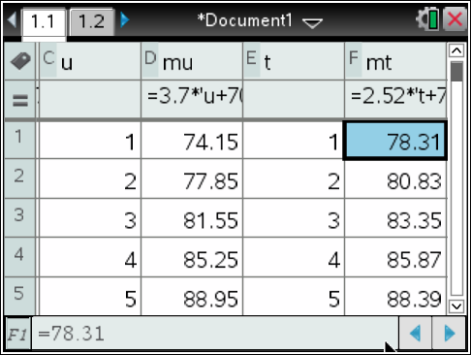 | 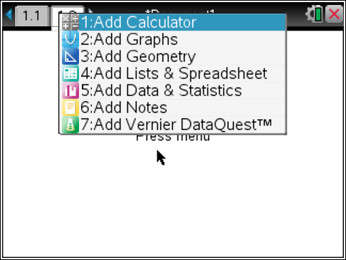 | 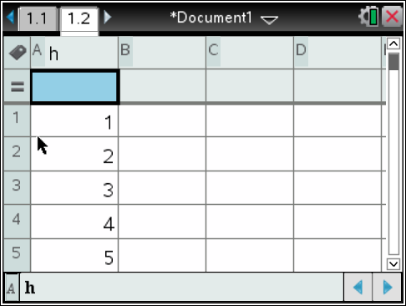
 | Column B is going to be for the female height rule using the humerus.  In the second column, in the B box, type the letters ‘fh’ and press enter. | In the formula box in Column B, type  3.36 × h + 57.97  and press enter.  Again, with the error message, choose variable and press enter.  Your data will be displayed. | In the third column, in the C box, type the letter u and press enter.  The data will automatically generate.
 | 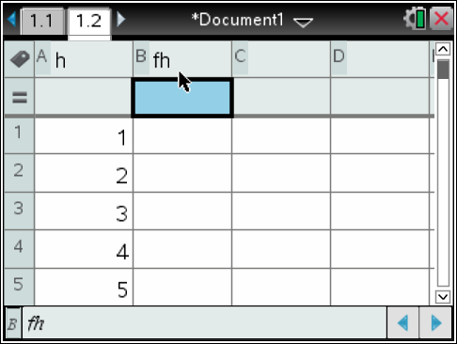 | 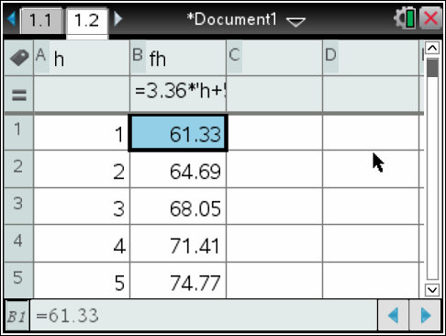 | 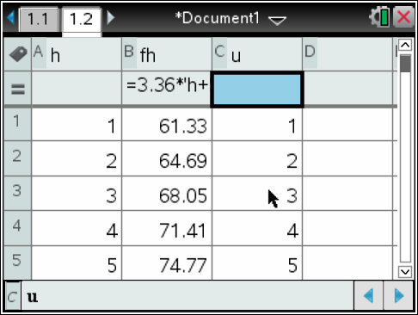
 | Column D is going to be for the female height rule using the ulna.  In the fourth column, in the D box, type the letters ‘fu’ and press enter. | In the formula box in Column D, type  4.27 × u + 57.76  and press enter.  Again, with the error message, choose variable and press enter.  Your data will be displayed. | In the fifth column, in the E box, type the letter t and press enter.  The data will automatically generate.
 | 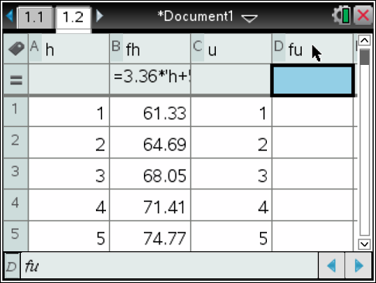 | 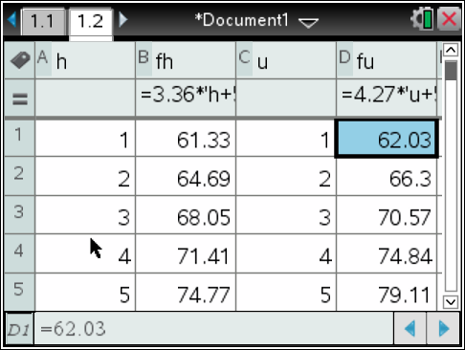 | 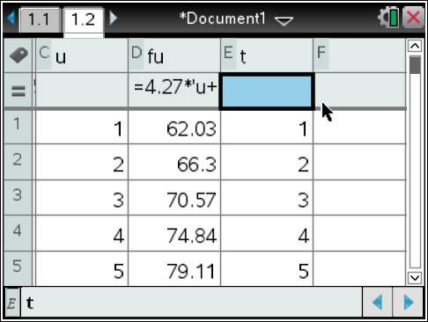
 | Column F is going to be for the female height rule using the tibia.  In the sixth column, in the F box, type the letters ‘ft’ and press enter. | In the formula box in Column F, type  2.90 × t + 59.24  and press enter.  Again, with the error message, choose variable and press enter.  Your data will be displayed. | Your spreadsheet is now complete.  You can toggle in between pages by either using your cursor and clicking on the tabs at the top, or pressing CTRL + left/right button on the Nav Pad.
 | 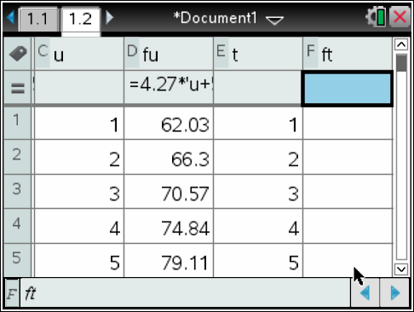 | 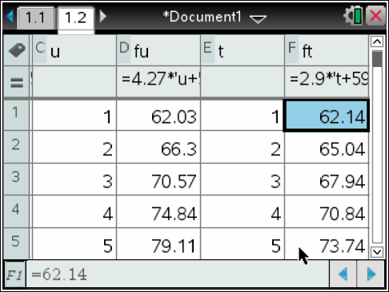

5. | Using the male spreadsheet, determine the values in the following cells:
a) | B15 | b) | C27
c) | D80 | d) | F34

6. | Using the female spreadsheet, determine the values in the following cells:
a) | B26 | b) | A52
c) | D41 | d) | F76

7. | Using your spreadsheet, determine the length of each of the bones, if the male body was known to have a height of 185 cm. Give your measurements as the closest to the height.

8. | Using your spreadsheet, determine the length of each of the bones, if the female body was known to have a height of 163 cm. Give your measurements as the closest to the height.

 |  | As you have defined formulas in a spreadsheet, you can use these in any other page in the CAS calculator. One simple feature of this is in the calculator page as substitution.
 | In the same document, we are going to create a Calculator page  Press CTRL+DOC.  This will insert a new page. Choose Calculator. |  | We can only use this if we want to subsitute a bone length into one of the given formulas.  To do this, we type the fomula subject, followed by sqaure brackets and the length we are looking for.  For example, if we want to find the height of a male given an ulna of 56 cm in length, we would type  mu[56  and press enter. | This tells us that the height of the male would be 277.65 cm or 278 cm, rounded to the nearest whole number.
 | 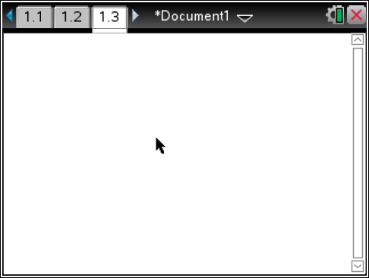 |  | 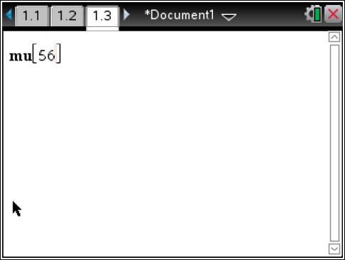 | 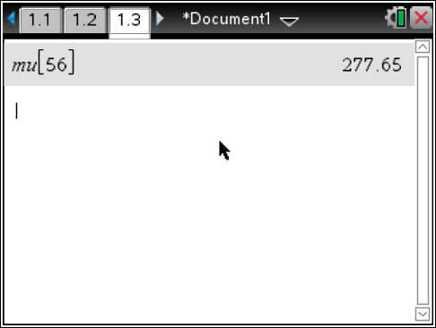

9. | Using the calculator page of your CAS calculator, determine the height of the following people:
a) | Male with an ulna of length 27 cm | b) | Female with an ulna of length 32 cm
c) | Male with a humerus of length 52 cm | d) | Female with a humerus of length 47 cm
e) | Male with a tibia of length 38 cm | f) | Female with a tibia of length 29 cm

10. | The following bones were recovered from the Lake Walyungup crime scene.
Bone Number | Type of Bone | Length (cm) | Sex | Calculated Height
1 | Humerus | 38.2 | Male
2 | Tibia | 38.9 | Female
3 | Ulna | 25.4 | Male
4 | Ulna | 31.8 | Male
5 | Humerus | 33.9 | Female
6 | Tibia | 44.5 | Male

a) | Complete the Calculate Height column.
b) | Is it possible any of these bones came from the same person? Which bones?
c) | What is the minimum number of bodies buried at this site?
d) | According to Py Thagoras’s medical records, he was 188 cm. Is it possible these bones belong to him?

11. | Two more bones were uncovered. One was an ulna bone and the other was a tibia bone.
a) | If it is known that the bones ‘belong’ to a female and the ulna bone is 30 cm long, who long should the tibia bone be?
b) | If the ulna bone is 28 cm long and the tibia bone is 39 cm long, predict whether the bones ‘belong’ to a male or female. Explain your reasoning.

